TITLE OF REPORT:
DEVELOPMENT OF A WEBSITE PHISHING DETECTION SYSTEM

PRESENTED BY
OSEMEKE, MIRABEL OLUCHUKWU
REGISTRATION NUMBER: 11305217BB
MATRICULATION NUMBER: 21/095244055
DEPARTMENT OF COMPUTER SCIENCE

UNIVERSITY SUPERVISOR:
DR. EDIM
DEPARTMENT OF COMPUTER SCIENCE
FACULTY OF COMPUTING
UNIVERSITY OF CALABAR

DATE OF SUBMISSION:
NOVEMBER, 2025

CHAPTER ONE

INTRODUCTION

1.1 Background of the Study
In the current digital era, security experts are increasingly concerned about phishing. This is owing to the fact that there is a high propensity and a comparatively simple way for attackers to produce phony websites that defaces its original counterpart. Phishing is a form of social engineering in which attackers impersonate a trusted organization or individual to trick users into divulging sensitive data - passwords banking credentials, or personal information. Phishing remains one of the most prevalent and financially damaging cybersecurity threats today; the FBI’s Internet Crime Complaint Center regularly reports more phishing incidents than any other category of cybercrime being responsible for an estimated USD 17.4 billion in global losses in 2024, a 45% increase over the previous year - 2023. Across all cyber-incidents, phishing features in 36% of breaches, while social engineering is implicated in over 80%. In 2025, the average cost of a phishing-related data breach is now nearly USD 4.9 million for affected organizations.
Although experts are able to recognize these fraudulent websites, many users are not, leaving them open to phishing scams. The following is a condensed description of how hackers execute phishing attacks: Usually, they send spam emails stating that your password for the university network is about to expire. The email provides a link to update your password, but clicking on it redirects you to a hacker-controlled server where they can steal your online data. In our project, we aim to predict whether a website is a phishing site or a legitimate one. We've collected the dataset from Kaggle^{[1]}. URLs with no malicious detection are labeled as '-1' (benign), while the detected ones are labeled as '1' (malicious).
We're exploring various machine learning algorithms to analyze the characteristics of these URLs. By understanding the features that indicate phishing, we hope to improve detection strategies. Phishing attacks often succeed due to a lack of consumer awareness, exploiting weaknesses in users.
Traditional detection methods - such as static rule-based heuristics and signature-based blacklists - are increasingly ineffective against zero-hour phishing campaigns, as newly created malicious URLs or obfuscated phishing sites can appear hours before appearing in any blacklist. Hence, Machine learning has emerged as a critical countermeasure and the greatest arsenal in an experts arsenal in this evolving landscape, and in the race against cyber-warfare.
One common technique to tackling this attack is updating blacklisted URLs and IPs in antivirus databases, known as the "blacklist" method. However, attackers constantly find ways to bypass blacklists through tactics like URL obfuscation, fast- flux (rapidly changing proxies), using homoglyph substitution, URL shortening, embedded IP addresses, algorithmically generating new URLs, and benign redirects to evade detection. To lure people in, phishers send mass emails, prompting users to visit a spoofed website. These sites often trick users into running software or downloading files. Malicious URLs can be detected using machine learning techniques, providing a more efficient solution compared to traditional methods. For better protection against phishing, it's essential for individuals to understand how these websites appear in their browsers. High-end companies can employ machine learning and deep neural network algorithms to proactively blacklist or detect phishing websites early. Machine learning helps catch phishing websites by learning from examples of both real and fake sites. It looks for signs like strange web addresses or tricky content that are common in phishing. Once it learns what to look for, it can quickly decide if a new website seems like a phishing threat or not. This smart system works faster than older ways of finding phishing sites, making it better at keeping users safe from online scams.
Essentially, machine learning acts like a smart detective that's always learning and staying one step ahead of the tricks that hackers use to create fake websites. Machine learning particularly URL-based detection, provides an effective countermeasure by analyzing URL lexical features in real-time. Leveraging meaningful features particularly from URL structures will aid ML-based systems in identifying malicious URLs in real-time, even before a page renders. Peer-reviewed studies confirm accuracy levels exceeding 97% using models like Random Forest, XGBoost, CatBoost, and Neural Networks, and LSTM Stacking. URL-based systems, by analyzing characteristics such as length, token patterns, special characters, IP address usage, and hyphen placement, enable lightweight yet robust phishing detection suited for deployment on server or client-side platforms.
Machine Learning in addition has proven to be the best approach to deal with such important aspects of Machine learning serves as a transformative paradigm in constructing real-life models by enabling computational systems to autonomously learn and derive insights from data, subsequently facilitating informed decision-making. This methodology obviates the need for explicit programming, allowing models to discern intricate patterns and extrapolate predictions. This project builds on these advances: constructing a robust and extensive URL-feature extraction pipeline, evaluating mutiple classifiers including but not limited to Extreme Gradient Boosting - XGBoost, and deploying a real-time Flask application.

1.2 Problem Definition
Online phishing is one of the most common attacks on the modern internet. Phishers use the sites which are visibly and semantically like those of authentic websites. Users frequently fall victim to phishing scam because malicious URLs often closely mimic benign websites. Despite evolving phishing tactics and increasing investments in cybersecurity, many cybersecurity solutions still depend heavily on blacklists, static heuristics or signature-based detection, incapable of identifying brand-new phishing sites, and unable to detect novel or short-lived phishing attempts effectively as phishing attacks continue to exploit user behaviour and system blindspots.
Such limitations leave users exposed in the “blind window” before listing in threat databases. Similarly, organizations remain vulnerable during the “listing window” when phishing URLs are newly created and not yet flagged in threat feeds. Moreover, attackers increasingly use techniques like homoglyph substitution, URL shortening, benign third-party redirection, hidden execution scripts, URL obfuscation, AI-generated spear-phishing, and dynamic content to bypass conventional defenses and evade naive detectors.
The problem is derived after making a thorough observation and study about the method of classification of phishing websites that makes use of machine learning techniques. This paper aims to answer the research problem below -
How can an effective, real-time phishing detection system be constructed using only URL-derived lexical features - capable of accurately identifying and classifying sites accurately immediately upon URL submission and supporting deployment in real-world environments?
This would be achieved by designing a system that should be able to:
- Accurately and efficiently classify the websites into legitimate or phishing.
- Time consumed for detection should be less and should be cost effective.

1.3 Aim and Objectives of Study
The aim of this study is to design, implement, and deploy an accurate, explainable, real-time phishing detection system by leveraging URL-based features and machine learning, capable of deployment via a web interface and resilient to emerging attack tactics. The specific objectives are:
- •Develop a comprehensive URL feature extraction pipeline capable of capturing lexical, structural, lexical attributes, and pattern-based features such as length, token counts, hyphens, presence of IPs/@ symbols, special characters, domain and path segmentation.
- •Train, validate, implement, and compare multiple supervised ML models, including Random Forest, Gradient Boosting (e.g., XGBoost), Support Vector Machine, Naives Bayes, K-NN, Logistic Regression, and MLP - selecting the best-performing model.
- •Use feature selection and explainable AI techniques (e.g;, Information Gain, feature importance ranking, SHAP or LIME, or recursive feature elimination) to prune, interpret model predictions, enhance trust and interpret feature importance for model explainability.
- •Containerize the chosen model and feature extraction system within a Flask application for URL submission and classification via an HTTPS endpoint.
- •Deploying the system using Render platform, enabling real-time access and testing.
- •Evaluating system and model performance using standard metrics - accuracy, precision, recall, F1-score, ROC/AUC - and compare across models and classifiers.
- •Assess system robustness to zero-hour and adversarial URL variants, analyzing potential weaknesses and mitigation strategies.

1.4 Research Justification
Phishing attacks accounts for significant financial, reputational, and operational risks worldwide - from individual users to multinational businesses and corporations billions yearly; notably, US businesses lost an estimated US $2 billion in a single year due to phishing-related fraud. As phishing-as-a-service (PhaaS) platforms proliferate, attack volumes and sophistication escalate rapidly. By 2025, cybercrime damages are projected to exceed USD 13.8 trillion, with phishing remaining a core driver. Business Email Compromise (BEC) alone caused USD 2.1 billion in financial losses in 2025 in the financial sector - 45% of which were phishing-initiated.
Machine learning offers adaptive and scalable detection, offering agility over traditional-signature or rule-based defenses by learning from patterns in data and adapting to new attack tactics. Research shows ensemble methods like Random Forest or XGBoost consistently outperform simple classifiers, reaching upwards of 99% accuracy on balanced datasets. While deep learning models (e.g., Bi-LSTM, stacking) show high accuracy (>96%), they often operate as opaque black boxes. Integrating explainability tools like SHAP or LIME - as explored in frameworks such as EXPLICATE, which achieved 98.4% accuracy with user-friendly natural language explanations - bridges the gap between automation and trust.
Furthermore, feature selection and explainability frameworks (e.g. SHAP) are critical to ensuring trustworthy ML-based systems that are crucial in cybersecurity applications where transparency and auditability are vital. Given the dynamic nature of phishing, a deployed real-time system using URL features alone provides a fast, lightweight, and scalable solution for organizations, especially in resource-constrained settings. The approach I employ emphasizes not only robust detection accuracy, but also interpretability and live deployment. For award-level research, this blend of technical rigor, transparency, and practically offers significant impact. It builds on a robust dataset and evaluated models, directly addresses these real-world needs.

1.5 Scope of Study
In this project, the primary focus has been on leveraging machine learning techniques and deep learning techniques to assess and detect phishing websites with binary classification of links as either "legitimate" or "phishing" based solely on URL-derived features and some HTML (version 5.0) hyperlink attributes. The core of our approach lies in the utilization of various algorithms for training and prediction purposes. To implement this, we have employed the Flask framework, a powerful Python web framework, and seamlessly integrated multiple libraries catering to diverse functionalities. Our choice of algorithms encompasses a comprehensive set, including Random Forest, Decision Tree, Support Vector Machine (SVM), K-Nearest Neighbor, Naive Bayes, Gradient Boost and Multi-layer Perceptron. These algorithms serve as the backbone of our predictive model each contributing unique strengths to the overall accuracy of link classification with performance benchmarking across metrics and feature selection experiments.
The implementation involves a two-step process: training the algorithms on a labeled dataset to learn the patterns associated with good and bad links, and subsequently, utilizing trained models for real-time prediction of new links. By employing this combination of machine learning algorithms and performance evaluation metrics, we aim to provide a robust and accurate solution for link classification, ensuring the reliability and efficiency of our system in distinguishing between good and bad links, including detection accuracy, explainability insights (feature importance), and preliminary resilience against evasion and adversarial perturbations.
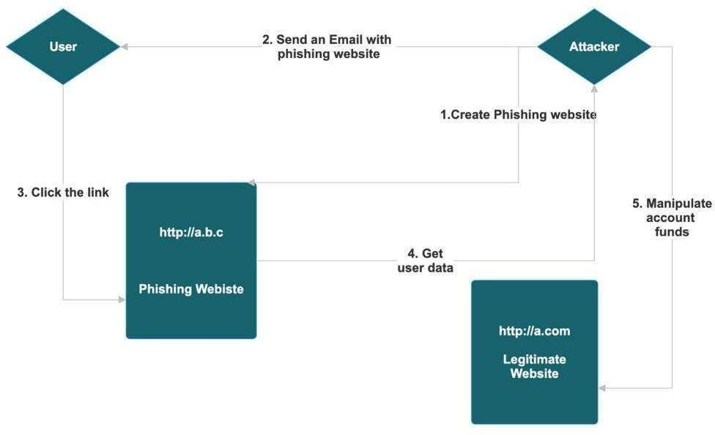

Figure 1.5 Flow of Methodology

1.6 Limitation of Study
However, the study has limitations. It relies on URL-based features only; as a result, complex content analysis or behavioral metrics are not included. The exclusion of content-based or contextual features (e.g., page rendering, WHOIS metadata) may limit detection of advanced evasive techniques like benign redirect loops or dynamically generated phishing pages. Furthermore, the reliance on URL-derived features excludes detection of phishing hosted behind benign redirects or when attackers employ homograph attacks or dynamically rendered JavaScript content.
Also, model performance is limited by the representativeness and balance of the dataset as zero-hour detection efficacy is limited by dataset diversity and adversarial evasion still remains a risk, so dependence on dataset quality and representativeness may affect performance on unseen phishing variants. In addition to that, adversarial attacks (e.g., URL obfuscation, poisoning) may bypass models without additional mitigation (e.g., adversarial training or ensemble defenses). Lastly, the lack of integration with external context (e.g., domain reputation, WHOIS, hosting IP geolocation) reduces detection depth.

1.7 Definition of Terms
- •Phishing: A fraudulent attempt to obtain sensitive information by impersonating or masquerading a trustworthy or trusted entity, typically via deceptive URLs, emails or smishing (SMS Phishing) and other communication channels.
- •Zero-Hour Phishing: Newly launched phishing sites that emerge before they appear in blacklists. They are undetected by blacklists at the time of creation or by current threat intelligence feeds.
- •Lexical URL Features: Structural and textual traits or characteristics derived directly from the composition of the URL string (e.g., token counts, length metrics, presence of special symbols or IP addresses).
- •Explainable AI (XAI): Techniques like SHAP or LIME that expose the contribution of individual features to model predictions, enhancing transparency and trust. They are also methods used to interpret model predictions and understand which features derive decisions.
- •Adversarial Machine Learning: Techniques attackers use to manipulate input - URLs - to cause misclassification; includes homoglyph substitution and URL obfuscation.
- •Machine Learning (ML): A subset of AI using algorithms to learn from data for the purpose of classification or prediction.
- •Feature Extraction: Process of converting raw URLs into measurable patterns (e.g., number of dots, special symbols, length metrics, etc.
- •Gradient Boosting / Random Forest: Ensemble ML algorithms that build strong classifiers from multiple decision trees.
- •Flask: A lightweight Python micro-framework used to create a web-based API/UI for real-time URL classification by supporting Rapid Application Development (RAD).
- •Render: A fully-managed cloud application platform designed to simplify deployment and hosting for developers that supports web applications, static sites, and databases.

1.8 Chapter Layout
CHAPTER 1 - INTRODUCTION
•This chapter serves as a project and launching pad to provide a comprehensive background for secure cloud backup and recovery. It includes an introduction to the project, defines the problem, outlines the objectives, reflects the purpose and motivation of the project and decides the organization of the project preview report.
CHAPTER 2 - LITERATURE REVIEW
•This chapter focuses on extensive research and integrates information from a variety of reputable sources, including standard books, journals, websites, and technical publications. The pertinent literature is printed, prior research on the subject is highlighted, and vital traits in cloud storage, backup, healing, and encryption are mentioned.
CHAPTER 3 - SYSTEM ANALYSIS AND DESIGN METHODOLOGY
•This chapter discusses the technical additives in the order of requirements and evaluation, venture planning, and architecture. It covers the statistics education and implementation system and introduces the most vital parts which include code samples, algorithms, equipment and strategies. The fundamental difficulties of the development procedure and the way to remedy them are also examined.
CHAPTER 4 - SYSTEM IMPLEMENTATION
•This chapter discusses the trying out technique, emphasizing the devices and strategies used to evaluate the platform and its performance, emphasizing the platform and ensuring reliability. It presents a thorough evaluation of the system with the aid of supplying a summary of take a look at instances and their outcomes.
CHAPTER 5 - SUMMARY, CONCLUSION AND RECOMMENDATIONS
•This insightful chapter provides an overview of the project and key findings, limitations and industry contributions. It follows with recommendations for future research pathways, paving the way for more investigation and innovation by providing guidelines for fine-tuning testing procedures, investigating additional performance indicators, and addressing outstanding problems.

CHAPTER TWO

LITERATURE REVIEW

2.1 Chapter Overview
This chapter defines phishing and explains how automated detection systems work, focusing on machine learning approaches. Section 2.1.1 introduces the concept of phishing, including its forms and motivations. Section 2.1.2 discusses the principles of phishing detection, contrasting manual and automated strategies. Section 2.1.3 categorizes major types of phishing detection systems (e.g. list-based, heuristic, ML-based). Section 2.1.4 traces the evolution of phishing attacks over time, noting trends like business-targeting and Phishing-as-a-Service (PhaaS). Section 2.1.5 outlines the key functionalities of a modern phishing detection system (feature extraction, classification, user alerting, etc.). Section 2.1.6 highlights the benefits of such systems (reduced financial loss, faster response, user protection). Section 2.2 reviews relevant literature on ML-based phishing detection, summarizing recent survey and experimental studies. Finally, Section 2.3 describes related works and frameworks, including recent projects that integrate detection with explainability or real-time warning (e.g. EXPLICATE, PhishXplain).

2.1.1 Concept of Phishing
Phishing is a social-engineering attack in which an attacker masquerades as a trusted entity to trick victims into revealing sensitive information. In practice, attackers use spoofed emails, instant messages, or fake websites that imitate legitimate services (banks, email providers, etc.) and lure users into clicking malicious links or entering credentials. For example, a typical phishing email may claim that “your password is about to expire” and prompt the user to visit a spoofed login page. The term “phishing” (with “ph”) alludes to earlier hacker culture (“phreaking”) and was coined in the 1990s during the first credential-stealing scams on AOL, and is believed to have first appeared in hacker tools like AOHell around 1994-1995. Over time, phishing has diversified into many forms: business email compromise (BEC), man-in-the-middle (MitM), in-session phishing, pharming (redirecting users at the DNS level to malicious sites without clicking links), spear-phishing (highly targeted emails), whaling (targeting executives), smishing (SMS-based), vishing (voice calls), and even quishing (QR codes) or social-media phishing. Regardless of the vector, the core goal is the same: steal login credentials, financial data, or install malware, often to commit fraud or identity theft. An example is a phishing email purporting to be a password renewal notice. The user is enticed to click a link leading to a fake website. Such attacks exploit trust and urgency to harvest credentials.

2.1.2 Conceptualization of Phishing Detection
Phishing detection systems aim to distinguish fraudulent sites or messages from legitimate ones. Early methods were manual (security teams maintaining blocklists or blacklists of known bad sites). Modern systems use automated techniques, from heuristic rules to machine learning (ML). In general, a phishing detector ingests data about a website or URL and outputs a verdict (e.g. “phishing” or “legitimate”). Successful detection hinges on features that capture telltale signs of fraud (in URLs, page content, or sending context) and learning from examples. Contemporary ML-based detectors treat phishing detection as a supervised classification problem: features are extracted from URLs and/or page content, and a model (e.g. a Random Forest or neural network) is trained on labeled datasets of phishing vs. benign sites. Compared to static blocklists or simple heuristics, ML techniques can generalize to new (zero-day) attacks and adapt to evolving phishing strategies. The vast majority of recent research applies ML: for example, Safi and Singh’s 2023 review found that 57 of 80 recent studies used machine learning algorithms for website phishing detection. Notably, Random Forest classifiers appeared in 31 studies and deep models such as Convolutional Neural Networks (CNNs) achieved accuracies as high as 99.98% in some tests. This shows that conceptualizing phishing detection as a data-driven ML problem yields powerful results, especially when comparing URL or content features against known patterns.

2.1.3 Types of Phishing Detection Systems
Phishing detection approaches can be grouped into several categories. These include traditional list- or rule-based methods and modern learning-based methods:
- •List-based detection: Uses blacklists/whitelists of URLs or domains. A site is flagged if its URL matches a known phishing blacklist (or fails to appear on a whitelist). This is fast and simple but fails to catch novel attacks (zero-day phishing).
- •Visual-similarity detection: Compares the visual or structural similarity between the suspect site and legitimate sites. For example, screenshot comparison or HTML-structure matching can reveal that a page is imitating a known brand. This can detect phishing that visually mimics a trusted site.
- •Heuristic (rule-based) detection: Applies hand-crafted rules or scores (e.g. checking for IP addresses in the URL, excessive URL length, obfuscated domain names, or presence of certain HTML/JavaScript patterns). These heuristics can catch some phishing traits but are brittle if attackers change tactics.
- •Machine learning (feature-based) detection: Extracts engineered features from the URL and/or website content (such as URL length, domain age, presence of login forms, HTML tags, external links, etc.), then uses a classifier (Random Forest, SVM, Gradient Boosting, etc.) to predict phishing. Many studies fall in this category. For example, Omari (2023) compared seven ML models (LR, KNN, SVM, NB, DT, RF, Gradient Boosting) and found that Gradient Boosting (with Random Forest) performed best on a benchmark phishing dataset.
- •Deep learning detection: Uses neural networks that can automatically learn features. CNNs can take rendered screenshots or processed HTML as input, while RNNs/LSTMs can process URL strings or email text. These models can implicitly capture complex patterns. Deep learning systems have achieved extremely high accuracy: Safi and Singh report a CNN model reaching 99.98% accuracy on a phishing dataset. Such models often outperform traditional ML in benchmarks, though they may require more data and computation.
In practice, modern phishing detectors often combine several methods (for example, an ML model plus blacklist checking). Some taxonomy studies list five main approaches: List-based, Visual-similarity, Heuristic, Machine Learning, and Deep Learning. The choice depends on deployment context: for real-time URL scanning, lightweight classifiers using only URL features are preferred for speed, whereas enterprise security systems may incorporate deeper content analysis.

2.1.4 Evolution of Phishing
Phishing has evolved rapidly since its origins in the mid-1990s, initially targeting AOL accounts, and evolved into mass email fraud in the 2000s. The 2010s saw Business Email Compromise (BEC) and ransomware campaigns, while the 2020s introduced Phishing-as-a-Service (PhaaS), lowering the skill barrier for cybercriminals (KELA Cyber, 2025). The increasing use of AI to generate convincing phishing content represents the latest challenge for detection systems.
Below is a brief timeline of key developments and notable transformations:
- •1990s: Phishing begins as attacks on AOL and early internet services (account credential theft via credit-card scams). These early scams coined the term “phishing” and targeted large user bases with generic traps.
- •2000s: As e-commerce grows, phishing moves into email spoofing of financial and payment sites (e.g. PayPal, banking portals). Large-scale email worms (e.g. the “ILOVEYOU” worm in 2000) illustrate how quickly scams can spread. Attackers register look-alike domains and use social engineering to harvest credentials and payments (the Google and Facebook tech giants report that up to 90% of cyberattacks begin with phishing). Attacks matured; Avalanche group executed high-volume comapigns (66% of APWG-recorded phishing in 2009) with custom kits.
- •2010s: Phishing becomes more sophisticated and targeted. Ransomware often arrives via phishing emails. Business Email Compromise (BEC) emerges: attackers impersonate suppliers or executives. In 2017, a CEO fraud scheme tricked Facebook and Google into wiring over $100 million by spoofing a legitimate vendor. Phishing is also used in political attacks (e.g. 2016 U.S. election hacks) and deploys HTTPS more widely, making scams harder to spot. Rise of ransomware-phishing blends (e.g., Cryptolocker), targeted BEC, and in-session phishing pop-ups.
- •2020s: Phishing scales up with commoditization and AI. “Phishing-as-a-Service” (PhaaS) platforms provide turnkey phishing kits, templates, and infrastructure to criminals. PhaaS lowers the technical barrier, enabling even unsophisticated attackers to launch highly targeted campaigns (often against corporate executives and IT staff). At the same time, attackers leverage AI to craft more convincing phishing content. The COVID-19 pandemic and remote work also expanded the attack surface. Phishing volumes remain extremely high: for example, the Anti-Phishing Working Group (APWG) reported over 1 million phishing attacks in Q1 2022. AI-powered personalization, multichannel attacks (smishing, vishing, quishing); pandemic-themed scams peaked; deepfakes heightening deception.
- •2024-2025: Generative AI tools escalate phishing effectiveness - a single malicious email now crafted every 42 seconds; malware samples are increasingly polymorphic. Tools like GhostGPT generate phishing content and portal replicas with anonymity and speed - fuelling the “automation of cybercrime”. Phishing-as-a-Service (PhaaS) platforms like Tycoon 2FA and Darcula have scaled operations globally - Darcula stealing nearly 884,000 credit cards over seven months.
Throughout this evolution, the underlying goal of credential theft and fraud remains constant, but tactics have adapted. Modern attacks often combine multiple channels (email, SMS, social media) and target specific industries. The rise of PhaaS and AI-generated phishing poses a particular challenge to detection systems, which must continuously update to recognize new templates and strategies.

2.1.5 Key Functionality of Phishing Detection Systems
A phishing detection system typically implements several core functions:
- •Feature extraction: The system automatically gathers relevant data from the URL and/or webpage. URL-based features might include length of the hostname, number of subdomains, entropy of characters, presence of IP addresses, or suspicious keywords. Content-based features include HTML tags (e.g. presence of <form> or many images), text content similarity to known sites, SSL certificate details, and other page elements. Both URL and content features are commonly used. Notably, content features require visiting the page, which is laborious and risky, whereas URL-only features are “lightweight” and can detect new attacks without fetching the site.
- •Classification/prediction: The extracted features are fed into a machine-learning model that has been trained to distinguish phishing from legitimate. Typical classifiers include Random Forest, Gradient Boosting (e.g. XGBoost or LightGBM), SVM, or neural networks. For example, Random Forest is widely used (31 out of 80 studies in one survey), and ensemble methods often outperform single models. A trained model outputs a probability or label. Advanced systems may employ deep learning (CNNs or LSTMs) which learn their own representations from raw input (screenshots or raw HTML).
- •Real-time alerting and blocking: Once a site or URL is classified as phishing, the system must act. This could be blocking the page in a browser (showing a warning), quarantining an email, or notifying security teams. Speed is important: real-time detectors (e.g. browser extensions) often use only URL-based models for rapid decisions, alerting the user before any damage occurs. Some solutions deploy as email filters or gateway proxies to stop phishing before it reaches users.
- •Explainability and user feedback (advanced): Modern frameworks increasingly include explainability layers so that detection decisions are understandable. For instance, systems like EXPLICATE use LIME/SHAP and large language models to generate human-readable explanations for why a site was flagged. Similarly, the PhishXplain extension highlights suspicious elements (words, links, etc.) on the page and provides contextual warnings. This function is not strictly necessary for detection, but it helps users trust and respond correctly to warnings.
- •Updates and learning: An effective system will continually update its models with new data. This includes incorporating feedback on false positives/negatives and integrating threat intelligence (new blacklists or phish reports). While not discussed in many academic papers, practical systems often retrain models periodically on fresh phishing datasets (e.g. from PhishTank or enterprise logs).
Overall, a ML-based phishing detector automates the identification process: it gathers features from suspicious links or pages, applies a trained model to classify them, and generates alerts or blocks. This pipeline – from feature extraction to user warning – is the essence of modern phishing detection.

2.1.6 Benefits of Phishing Detection Systems
Effective phishing detection systems offer significant benefits to organizations and users:
- •Reduced financial losses: By intercepting phishing attacks, organizations avoid the steep costs of data breaches and fraud. For example, a single corporate phishing incident can cost millions; the IBM/Ponemon Cost of a Data Breach Report (2024) estimates average phishing breach costs around $4.88 million. Notably, Google and Facebook together nearly lost $100 million in a 2013-2015 scheme, but quick detection and response helped recover most funds. Each prevented attack thus saves potentially millions of dollars.
- •Protection of credentials and data: Automated detectors catch many attacks that human vigilance might miss, stopping credential theft and malware delivery. This helps maintain the integrity of user accounts and corporate data, reducing downtime and remediation costs. It also protects sensitive customer information, preserving trust.
- •Improved security posture: Deploying detection tools raises overall security by providing early warnings. For instance, real-time URL analysis can block malicious links before users ever see them. Faster containment translates to lower impact; the IBM report notes that breaches contained earlier (within 200 days) cost about $1.2M less on average.
- •Scalability and efficiency: ML-based systems can scan vast volumes of emails and websites automatically, far beyond manual capacity. They operate continuously and update rapidly. The lightweight URL-only models allow client devices to pre-screen links in real time. This means even small security teams can effectively cover large user bases, and block large-scale campaigns quickly.
- •User training and trust: By flagging threats, detection systems educate users on what to avoid, indirectly training employees. When users see explainable warnings (especially those generated by advanced systems), they learn to recognize phishing cues. This reduces risky behavior over time. For end users, knowing that protective systems are in place (and effective) can increase confidence in the organization’s security measures.
In summary, deploying ML-driven phishing detection reduces risk at multiple levels: financially (by avoiding losses), operationally (by preventing breaches), and culturally (by raising awareness). These benefits are especially pressing given the high incidence of phishing (up to 94% of organizations experienced phishing attacks in recent surveys) and the increasing sophistication of attackers.

2.2 Review of Relevant Literature
Recent literature on phishing detection overwhelmingly emphasizes machine learning approaches. Safi and Singh (2023) conducted a systematic review of 80 papers from the last five years and found that Machine Learning is the dominant detection technique. In their survey, ML methods (especially Random Forest) were the most used, and CNNs achieved the highest reported accuracy (99.98%) on phishing datasets. They categorize detection techniques into Lists-Based, Visual Similarity, Heuristic, ML, and DL, with ML-based models outnumbering the others. Another recent survey by Asif et al. (2023) focuses on URL-based detection. They note that while websites usually allow features from URL and content, collecting content (by visiting sites) is costly and risky. Consequently, many researchers are exploring URL-only models for efficiency. Asif et al. review shows that URL-based systems can still achieve high accuracy; for example, Random Forest and LSTM models using lexical URL features have effectively detected phishing. They emphasize that URL-only models are lightweight (run on clients, catch zero-days) and have become a promising trend.
Empirical studies confirm the effectiveness of ensemble ML classifiers. Omari (2023) directly compared seven algorithms on a standard phishing dataset and found that Gradient Boosting combined with Random Forest yielded the best accuracy, outperforming SVM, Naive Bayes, etc.. Other experiments report similarly high performance: Kasim et al. (2021) used LightGBM with PCA to reach 99.60% accuracy on a phishing URL dataset, and Butnaru et al. (2021) achieved 99.29% with an optimized Random Forest model. Even simpler models can perform well: Sindhu et al. (2020) reported ~97% accuracy using RF, SVM and a neural network on 11,055 URLs. These results suggest that diverse ML techniques – from tree ensembles to deep neural nets – can all effectively distinguish phishing URLs.
Beyond raw accuracy, many studies also examine feature engineering and hybrid approaches. For instance, Yang et al. (2021) combined a CNN and Random Forest in a hybrid model, achieving 98.76% accuracy on a test set. Researchers have also proposed stacked or ensemble architectures: Aslam et al. (2024) introduced AntiPhishStack, an LSTM-based stacking model for optimized URL detection (publication in 2024). Similarly, researchers like Tanwar et al. (2020) have proposed integrating multiple classifiers (e.g. CNN for feature extraction plus SVM for classification) with promising results. Overall, the literature indicates that modern ML (including deep learning) is far superior to legacy methods; for example, signature/rule-based schemes that dominated the 2000s are now known to be vulnerable to zero-day attacks, whereas ML classifiers adapt to changing patterns.
Several comprehensive surveys reinforce these trends. Asif et al. (2023) note a lack of centralized datasets but emphasize that major ML algorithms (Random Forest, LSTM with lexical features) can detect phishing effectively without requiring page content. Similarly, Safi & Singh (2023) highlight that Random Forest and Convolutional Neural Networks are among the most common and best-performing methods. These reviews also point out that many studies use public phishing datasets (PhishTank, UCI, Kaggle) and evaluate on thousands of samples. The consensus is clear: ML models, especially ensemble trees and deep networks, yield very high detection accuracy, often above 95% and sometimes above 99%.
Other studies like EXPLICATE Framework (2025), combines ML classifiers with dual-layer explanations (SHAP + LIME) and LLM-enhanced natural language summaries. Achieved 98.4% accuracy with 94.2% explanation accuracy, improving usability and transparency. TSK Fuzzy Framework (2025), offer and explainable fuzzy logic-based model with near-perfect accuracy (99.95%) and interpretability via human-friendly rules and membership functions. VisualPhishNet (2019), a visual-similarity-based detection using triplet CNN, improving detection of zero-day, visually deceptive phishing pages. Springer AI Review (2024), highlights practical challenges - scaling, integration, continual retraining, and adversarial training (e.g., using GANs) - for deploying advanced detection in real-world infrastructures.
In summary, the relevant literature (2020–2025) shows a strong shift toward ML and DL techniques for phishing website detection. Random Forest and Gradient Boosting are frequently top performers, and deep models like CNNs have pushed accuracies to ~99%. Surveys agree on the categories of detection and the benefits of URL-based models for speed and zero-day coverage. These findings motivate the current project’s focus on ML-based detection and the comparison of modern algorithms (RF, XGBoost, CNN, etc.) on current phishing data.

2.3 Related Works
Recent work has produced several frameworks and tools for phishing detection that illustrate the state of the art. For example, EXPLICATE (Lim et al., 2025) is an ML-based system that combines a classifier with explainability modules: it uses a domain-feature ML model plus LIME/SHAP to provide feature-level insights, then employs an LLM (DeepSeek) to translate technical explanations into user-friendly language. EXPLICATE reports 98.4% detection accuracy across metrics while delivering high-quality explanations, demonstrating that high performance can be achieved alongside interpretability. Another recent project is PhishXplain (Roy et al., 2024), a browser-based real-time warning system. PXP captures the URL and page source, uses a memory-efficient LLaMA model to identify phishing indicators, and generates contextual alerts by highlighting suspicious elements on the page. In a month-long deployment, PhishXplain successfully issued explainable warnings for 94% of tested phishing sites (96% correctness) and significantly improved users’ ability to recognize phishing cues. Both EXPLICATE and PhishXplain exemplify how modern detectors can integrate ML with user-centric explainability.
Other related works include hybrid ML architectures and browser extensions. For instance, researchers have proposed stacked ML models (e.g. a CNN feature extractor feeding an SVM classifier) and ensemble learning approaches (combining multiple algorithms) to improve detection robustness. Some teams have even built Chrome extensions that block phishing (using ML rules) or augment Google’s Safe Browsing with additional filters. On the practical side, commercial systems like Google Safe Browsing and cloud-based email filters now incorporate ML heuristics learned from vast phishing datasets.
Notably, high-profile phishing events - e.g., 2016 U.S. election spear-phishing, Google/Facebook invoice scan ($100M), and Ubiquiti’s $47M loss - underscore phishing’s systematic impact. Over a million PhaaS attacks detected in early 2025; platforms like Tycoon 2FA use obfuscation and session hijacking to bypass 2FA. Generative AI enables highly realistic, personlized content at low cost, rapidly proliferating phishing attacks. Increasing use of combined email, SMS, voice, and QR code channels for phishing elicitation. In addition to that, emerging frameworks like EXPLICATE and TSK fuzzy models close the gap between automation and user trust in detection.
Finally, it is worth noting the role of attacker frameworks as context: the rise of Phishing-as-a-Service (PhaaS) platforms has been documented (KELA Cyber, 2025), showing that adversaries now have subscription access to sophisticated phishing kits. While not detection works themselves, such services underscore the need for advanced defense. By studying these real-world tools and incidents (e.g. the $100M Google/Facebook BEC case), researchers can better tailor ML detectors to emerging threats. In sum, related works span academic surveys, experimental classifiers, explainable frameworks, and insights from live incidents—all reinforcing the trends identified in this chapter.

2.4 Proposed Contribution to Knowledge
The present research seeks to advance the current state of phishing website detection by addressing several limitations identified in recent literature and practical deployments. While existing studies have demonstrated high accuracy using machine learning (ML) and deep learning (DL) models (Safi & Singh, 2023; Omari,, 2023), there remains a gap in lightweight, explainable, and adaptive phishing detection systems that can operate effectively in real-time without sacrificing accuracy or interpretability.
This study’s proposed contributions are outlined as follows:
- Integration of Hybrid Feature Engineering for Improved Detection Accuracy
•Unlike most studies that rely solely on either URL-based or content-based features, this research proposes a hybrid feature set that strategically combines both categories. URL features (e.g., length, entropy, domain age, presence of suspicious keywords) offer lightweight processing, while selected content features (e.g., HTML tag analysis, SSL certificate properties, keyword frequency) provide deeper contextual signals. This balanced feature design aims to maximize zero-day detection rates while maintaining computational efficiency, especially for client-side implementations.
- Development of an Optimized Ensemble Model for Real-Time Detection
•Building on evidence that Random Forest and Gradient Boosting models consistently outperform single classifiers (Omari, 2023; Kasim et al., 2021), this study proposes an ensemble-based architecture combining Random Forest, XGBoost, and a lightweight CNN. The CNN will process tokenized URL structures to capture implicit patterns, while the tree-based models will handle the engineered features. This multi-view learning approach is expected to improve generalization and resilience against adversarial obfuscations (e.g., homoglyph attacks, URL padding).
- Incorporation of Explainable AI (XAI) Techniques
•Inspired by frameworks like EXPLICATE (Kumar et al., 2025) and PhishXplain (Roy et al., 2024), this research will integrate SHAP (SHapley Additive exPlanations) to provide feature-level insights into model predictions. Unlike opaque black-box models, this approach will allow end-users and cybersecurity analysts to understand why a URL is flagged as phishing. This transparency is critical for increasing user trust, facilitating incident response, and enabling compliance with regulatory requirements such as the EU AI Act (2024).
- Design of a Real-Time, Resource-Efficient Detection Prototype
•The proposed system will be implemented as a web-based application and a standalone Python API, ensuring versatility in deployment. Special emphasis will be placed on resource efficiency, allowing the solution to run on low-end devices without significant performance degradation. This addresses a key gap in many deep learning-based solutions that require high computational resources, making them impractical for large-scale or real-time use in developing regions.
- Evaluation on Multi-Source, Up-to-Date Datasets
•Whereas many existing studies rely solely on static datasets such as the UCI or PhishTank archives, this research will curate a blended dataset combining multiple recent sources (2024-2025 phishing URLs from PhishTank, OpenPhish, and curated benign lists from Alexa Top Sites). This ensures that the model is trained and tested on contemporary attack patterns, including those leveraging HTTPS, punycode domains, and social-media-based phishing links.
- Contribution to Open-Source Security Tools
•To facilitate wider adoption and academic verification, the final implementation, along with the curated dataset and model training pipeline, will be released under and open-source license. This will contribute to the global security research community and encourage further innovation in phishing detection methodologies.
By combining hybrid features, optimized ensembles, explainability, resource efficiency, and up-to-date datasets, this research aims to produce a practical, accurate, and transparent phishing detection system. The resulting framework will bridge the gap between high-accuracy academic models and deployable, real-world solutions capable of countering the rising threats and evolving phishing strategies, including but not limited to Phishing-as-a-Service (PhaaS) and AI-generated attacks.

CHAPTER THREE

SYSTEM ANALYSIS AND DESIGN METHODOLOGY

3.1 Chapter Overview
This chapter presents the system analysis, development and design methodology for my phishing website detection project, as well as, a detailed analysis of the current phishing-detection systems. I begin by examining existing anti-phishing measures (user training and technical defenses) and identifying their strengths and weaknesses. I then define the proposed system’s functionality and requirements, and describe its developmental approach. I adopted the Waterfall model as the SDLC methodology – a linear, sequential approach where each phase flows into the next. The Waterfall model “sets distinct endpoints or goals for each phase” and is suitable here because my requirements are well-defined and unlikely to change. In Section 3.2, I analyzed the current versus proposed system, and in Section 3.3, I specified the system requirements and methodology. Section 3.4 outlines the system design with UML and data-flow diagrams to illustrate the architecture. This structured approach ensures that all requirements are clearly documented before implementation.

3.2 System Analysis

3.2.1 Analysis of the Existing System
Current phishing detection tools rely heavily on static methods: for example, web browsers and security software often use blacklists of known malicious URLs or fixed heuristic rules to flag dangerous sites. Additionally, anti-phishing efforts rely on a mix of user education and technical safeguards. These methods provide baseline protection for known threats but have well-known shortcomings. In particular, blacklist-based systems cannot detect previously unseen (“zero-day”) phishing pages, because those URLs are not yet listed. Heuristic or similarity-based detectors (e.g. URL pattern matching) may catch some novel attacks, but they suffer from accuracy and scalability issues. Some commercial solutions use third-party services (like search-engine blacklists), yet these can also fail on new benign or malicious domains. In practice, this means existing systems may miss new attacks or raise false alarms. As one review notes, “Anti-phishing strategies involve educating citizens and technical defense,” and recent work surveys how machine learning methods are being used to identify phishing sites. The analysis thus shows that current solutions work only for known threats: they quickly block familiar phishing sites but struggle to adapt to evolving attack tactics. While these measures provide a baseline defense, they generally treat phishing detection indirectly (through email or network filters) rather than via a dedicated automated system for analyzing arbitrary URLs in real-time.

3.2.2 Advantages of the Existing System
- •Ease of Use and Availability: Many browsers and email clients include built-in anti-phishing filters or safe-browsing lists. Users benefit from protection without installing extra software.
- •Established Infrastructure: Because these tools are mature and widely used, they already block a large proportion of known phishing sites, reducing risk for the average user.
- •Low User Effort: They require no action by most users (automatic updates, passive protection) and often have minimal impact on browsing speed for known threats.
- •Deterministic Behavior: Static rule-based systems are predictable and transparent; false positives can be checked against well-known patterns or databases.
- •Maturity and Low Cost: Many existing solutions (like blacklist checks and browser filters) are mature and easy to implement. For known phishing URLs, these tools can block threats almost instantly with minimal overhead.
- •User Awareness: Well-designed training programs and simulated phishing campaigns can significantly reduce the risk of user error. Educated users act as a human firewall against many common phishing lures.
- •Automatic Operation: Technical safeguards (spam filters, anti-malware, certificate checks) operate automatically once configured, providing continuous protection without user intervention.

3.2.3 Disadvantages of the Existing System
Despite these benefits, current methods have the following significant gaps:
- •Zero-Day Vulnerability: Static lists and rule-based filters struggle with new or obfuscated phishing sites. Such systems cannot detect novel phishing URLs or targeted attacks that are not yet in a blacklist. This delay allows new phishing sites to operate undetected until someone updates the list.
- •Maintenance Overhead: Blacklists and heuristic rules must be manually curated or frequently updated. In practice, this can lag behind attackers, and stale data can reduce effectiveness.
- •False Positives/Negatives: Heuristic filters may misclassify legitimate sites as phishing (causing user frustration) or miss cleverly disguised phishing sites. The trade-off between sensitivity and specificity is hard to manage. They often have high false-negative rates on clever new phishing schemes and require significant manual effort (updating rules, retraining users).
- •Lack of Adaptability: Traditional approaches cannot “learn” from new data on their own. They don’t improve without explicit updates, so novel attack patterns often slip through. In fact, recent research emphasizes that modern ML-based detectors “can detect harming attacks which are undetectable by many existing systems”. This implies that legacy approaches often miss sophisticated or zero-day phishing pages.
- •Scalability Issues: Some advanced heuristic or content-analysis methods (e.g. scanning page code or similarity matching) can be compute-intensive and may not scale well to millions of links per day.

3.2.4 Analysis of the Proposed System
The proposed system is designed to overcome these shortcomings by using machine learning (ML) and a modern deployment. The core idea is to build an ML-based classifier that learns patterns distinguishing legitimate and phishing URLs. Research shows that ML models are well-suited for this task: they can detect zero-day phishing attacks and scale to large data volumes while maintaining high accuracy. ML-based models are the only stream that shows the ability to detect 0-day phishing attacks while being scalable and accurate. In practice, this means the system will extract features from a URL (such as domain age, SSL usage, URL token patterns, etc.) and feed them into a trained classifier.
I will implement this as a web application so that end users can simply enter a URL and receive an instant verdict. Concretely, the backend will be a Flask (Python) server hosting the trained ML model, and the frontend will be a simple web interface. Users (after optional registration/login) will submit a URL, and the system will respond “phishing” or “legitimate” based on the model’s prediction. The system could also store scan history or allow administrators to retrain the model with new data. Importantly, our design leverages modern deployment tools: the application code will be version-controlled on GitHub and automatically deployed to a cloud hosting service (Render.com). Render supports one-click or automated deployments of Flask apps: as soon as code is pushed to the GitHub repository, Render will build and deploy a new live instance. This ensures continuous integration/continuous deployment (CI/CD) so the site remains up-to-date.
In summary, the proposed system uses machine learning and cloud deployment to provide dynamic, real-time phishing detection via a user-friendly web interface. This overcomes the static nature of existing tools and makes the solution accessible online (Flask+GitHub+Render) without requiring users to install software.

3.2.5 Algorithms of the Proposed System
As supervised machine learning is the foundation of my entire project. A subset of artificial intelligence and machine learning is supervised learning. The way it operates is that we feed a model data and a label, and after the model is trained, it finds patterns in the data, links the labels to those patterns, and generates new predictions. Supervised learning has an enormous range of possible applications. A few of them may be used for spam detection or spam detection. This is how we determine whether an email is spam or not: if it's spam, it will be automatically deposited in a spam folder; otherwise, it will be deposited in your inbox. Classifying objects is another, among many others. Two types of supervised machine learning exist:
- •Classification:
Not only does it assist in finding items that we can look up using keywords, but it also finds our inventions that are extremely similar to ours. A section that is divided into topic areas known as classes and subclasses. Predictive modeling is a sort of problem that involves estimating the mapping characteristic from input variables to discrete output variables. Take an email spam detector, for example. The main objective of a classification algorithm, which is specially designed to forecast the result for a given collection of data, is to choose the category for the dataset. An algorithm that implements the type using a dataset is called a classifier.

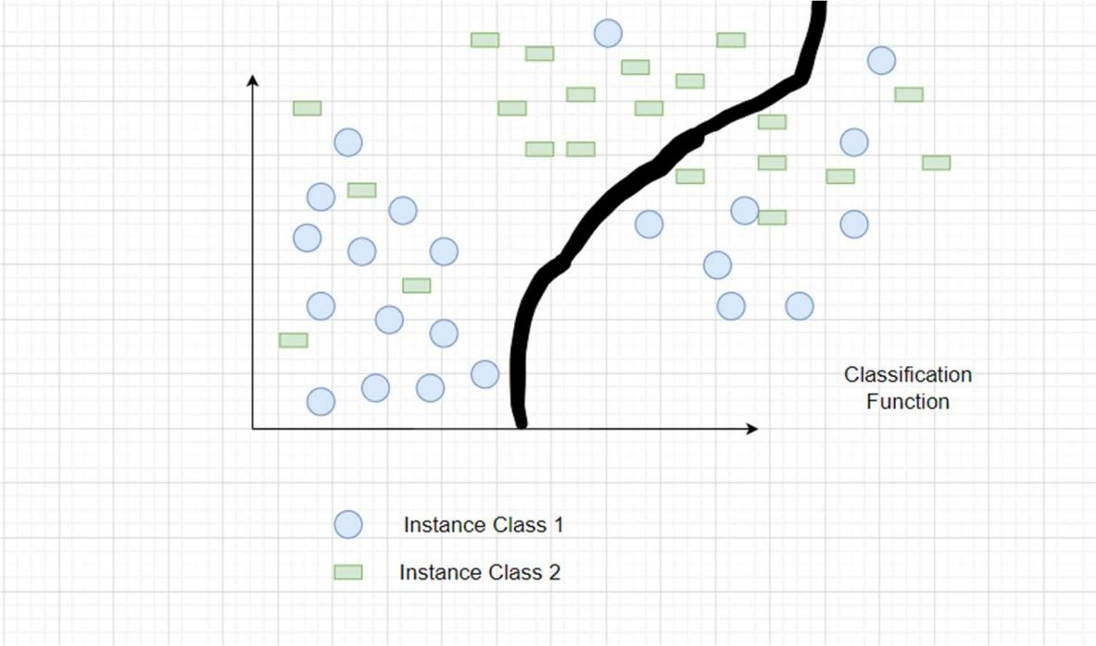
Figure 3.2.5.1 Classification

- •Regression:
It is a supervised learning technique that makes it possible to determine the correlation between variables and predict the continuous output variable based only on the most basic or significant predictor variables. Prediction, forecasting, time collection modeling, and determining the causal-impact relationship between variables are among its specific uses. Regression involves creating a graph with the variables that best fits the provided data points; by using this plot, the machine learning version of the data can be predicted.
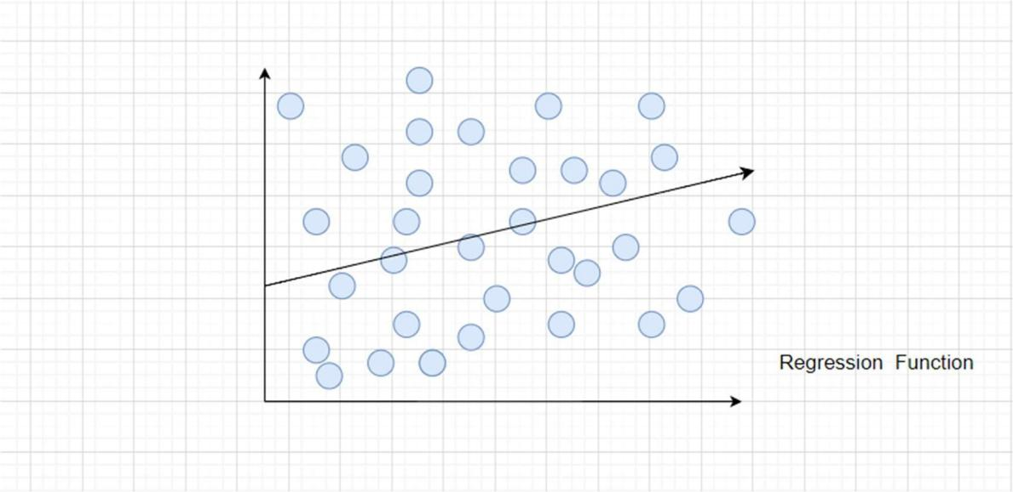

Figure 3.2.5.2 Regression

The Python framework, Flask, was used in the project and numerous libraries were imported for various uses. Eight algorithms were selected: Random Forest, Decision Tree, SVM, Gradient Boost, Naive Bayes, K-Nearest Neighbor, Logistic Regression and Multi-layer Perceptron. Thus, this contains a variety of URL types, including phishing, benign, and spam URLs. The dataset was outsourced from Kaggle which consists of 11,054 rows and 32 columns.
Various machine learning algorithms were examined for analyzing the characteristics in order to gain a thorough understanding of how the URLs that propagate phishing are constructed. For this project, the supervised machine learning techniques and deep learning techniques that we have selected are:
- •Random Forest:
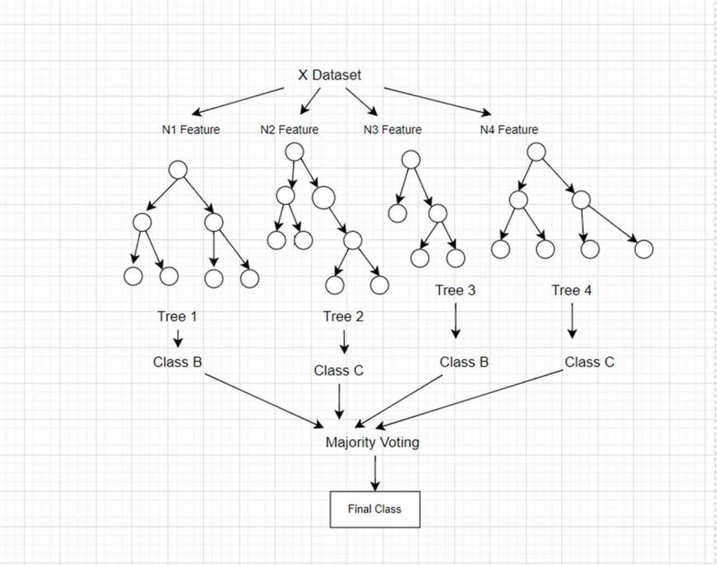
Many random decision trees make up a random forest. The trees contain two different kinds of randomness. Every tree is initially constructed using a random sample of the initial data. Secondly, to produce the best split, a subset of features is randomly chosen at each node in the tree. More trees will prevent the model's trees from being overly fitted. The majority of the data will remain accurate while the missing values are handled by the random forest classifier.

Figure 3.2.5.3 Random Forest

- •Decision Tree:
A random forest is made up of several random decision trees. There are two distinct types of randomness in trees. Each tree is first built with a random subset of the original data. Second, at each node in the tree, a subset of features is randomly selected in order to generate the best split. The model's trees won't be unduly fitted with more trees. While the random forest classifier fills in the missing values, the majority of the data will continue to be accurate.
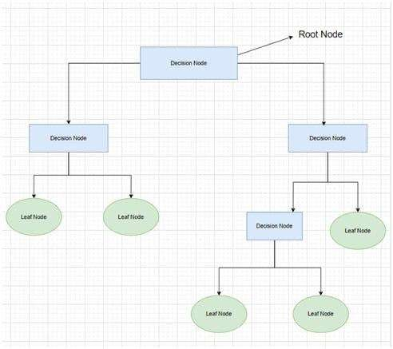

Figure 3.2.5.4 Decision Tree

- •SVM (Support Vector Machine):
Support vector machines (SVMs) are supervised machine learning algorithms that are versatile and strong, and they are utilized for both regression and classification. However, they are typically applied to classification issues. In essence, a hyper-plane in multidimensional space, the Support Vector Machine (SVM) model represents different classes. To reduce the error, the SVM will create the hyper-plane repeatedly. SVM seeks to determine a maximum marginal hyper-plane (MMH) by classifying the datasets.
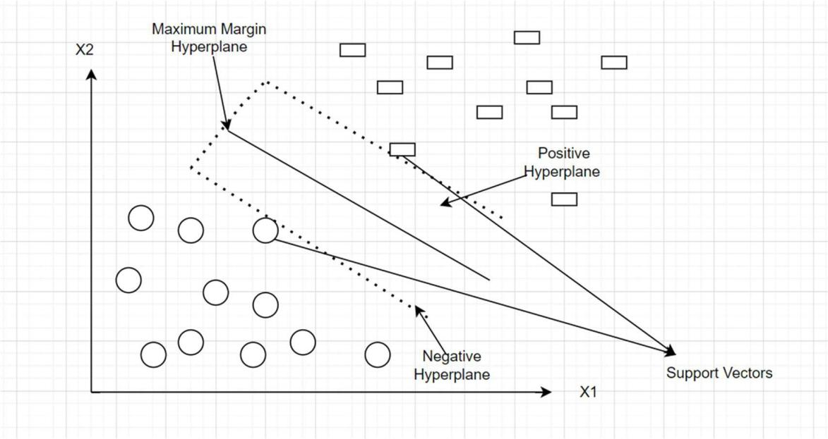

Figure 3.2.5.5 Support Vector Machine

- •Gradient Boost:
Under the Gradient Boosting framework, XGBoost is an open-source software library that implements optimized distributed gradient boosting machine learning algorithms. Gaining a thorough understanding of the machine learning principles and techniques that supervised machine learning, decision trees, ensemble learning, and gradient boosting are based on is essential to comprehending XGBoost. XGBoost is the ideal fusion of hardware and software capabilities created to optimize current boosting methods with maximum speed and accuracy. It is, in general, this algorithm's feasibility, accuracy, and efficiency. It contains algorithms for both tree learning and linear model solving. Therefore, its ability to perform parallel computation on a single machine is what gives it its speed.

- •Flask:
A lightweight Python web framework called Flask was created to make creating web apps and APIs easier. The WSGI (Web Server Gateway Interface) standard is adhered to, and it offers a simple and uncomplicated method for developing websites. Fundamentally, Flask helps developers create web applications by providing necessary tools and conventions, freeing them up to concentrate on writing application logic instead of managing the intricate details of handling HTTP requests and responses. The framework is a well-liked option for projects ranging from small prototypes to larger-scale applications because of its simplicity, adaptability, and ease of use. Because Flask has a modular architecture, developers can easily add more features by integrating different extensions for things like form handling, database interaction, and authentication.

- •Naive Bayes:
"Naive Bayes classifiers" refers to the class of classification algorithms that use Bayes' Theorem as its foundation. Rather than being a single algorithm, it is actually a family of algorithms built on the same principle: every pair of characteristics that is being classed stands alone. It is based on the Bayes theorem. Based on the probability of a previous occurrence, the Bayes Theorem determines the likelihood of a current event. Naive Bayes classifiers are straightforward probabilistic frameworks in statistics that apply the Bayes theorem. The likelihood of a hypothesis given the available information and some prior knowledge forms the basis of this theorem. Given that each feature in the input data is assumed to be independent of every other feature, the naïve Bayes classifier often assumes that false in real-world situations. Despite this oversimplifying assumption of an extra incident that has already happened, the naive Bayes classifier is still widely utilized due to its effectiveness and high performance in several real-world applications.

- •Multilayer Perceptron:
An MLP comprises an input layer, one or more hidden layers, and a layer for output. It is a specific type of feed forward artificial neural network. All of the layers are completely interconnected. An essential idea in deep learning and neural networks will be covered in this article: the Multiple-layer Perceptron Neural Network. The only direction in which the Multilayer Perceptron (MLP) Neural Network may operate is forward. Every node is completely linked to the network. Every node only transmits its value in a forward way to the subsequent node. Backward propagation is an algorithm used by the MLP neural network to improve training model accuracy.
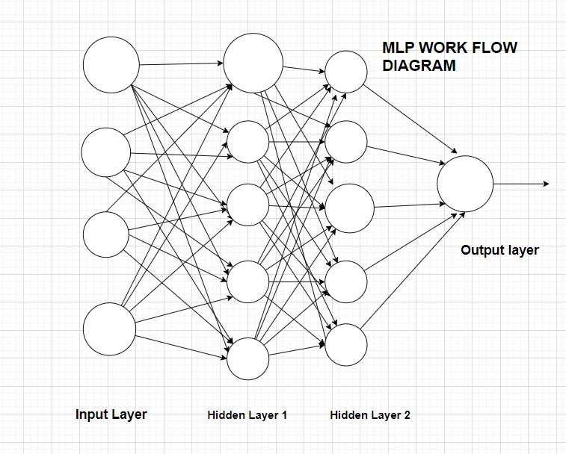

Figure 3.2.5.6 Multilayer Perceptron

- •Logistic Regression:
Logistic regression (LR) is a supervised machine learning technique used to assess the likelihood of an event, a result, or an observation to resolve binary classification problems. The model's output is usually binary, meaning it can be either true or false. Logistic regression is a technique used to sort data according to the degree of correlation between one or more independent variables. It is frequently used in predictive modeling, in which an event's mathematical likelihood of falling into a particular category or not is determined by the model. In binary classification problems, where the outcome variable indicates one of the two categories (0 or 1), logistic regression is frequently utilized. The sigmoid function, a logistic function, is used to map predictions in logistic regression. In addition, if the estimated probability generated by the sigmoid function over a predefined threshold on the graph, the model predicts that the instance belongs to that class. The model states that if the computed probability is less than the preset threshold, the instance does not belong in the class.

- •K-nearest neighbor:
A supervised, non-parametric learning technique is the k-nearest neighbors algorithm (KNN). A data point's classification or grouping is predicted according to how close it is to nearby points. KNN is a flexible technique that is frequently used in machine learning for a range of regression and classification applications. KNN is an acronym for K-Nearest Neighbor. It's an algorithm for supervised machine learning. Problem assertions involving regression and classification can both be resolved by the algorithm. The sign "K" indicates the number of closest neighbors to a new unknown variable that has to be classed or forecasted. KNN determines the separation between every point in the vicinity of the unknown data and eliminates those that have the shortest distances to it.
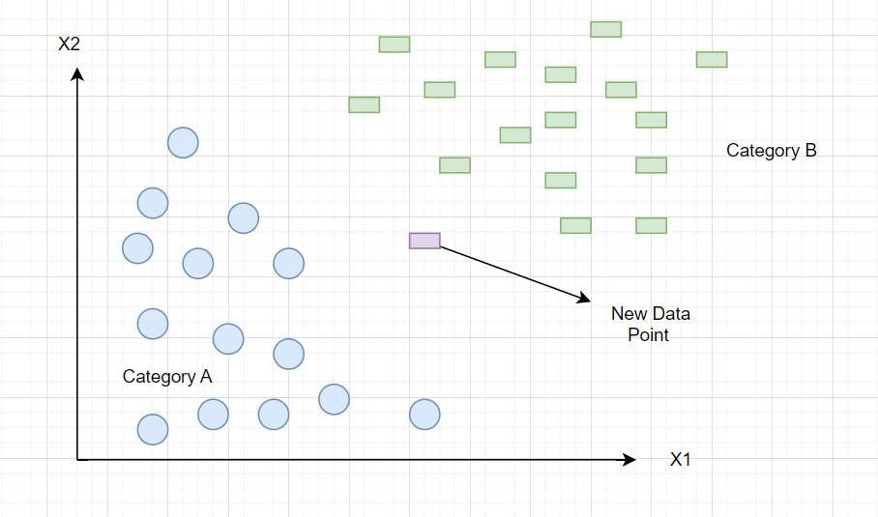

Figure 3.2.5.7 K-Nearest Neighbor

3.2.6 Algorithmic Design of the Proposed System
This project focused on using machine learning techniques for link classification (good or bad), by implementing Flask, a Python framework, and incorporated algorithms like Random Forest, Decision Tree, KNN, Naive Bayes, Logistic Regression, Multilayer Perceptron and Gradient Boost. The classification report, featuring metrics such as recall and precision, evaluates the models' performance. My approach ensures accurate and reliable link classification by leveraging diverse algorithms and thorough performance analysis. Alternatively, the collection of phishing URLs is simple because of the open source supplier known as Phish Tank. This supplier offers a set of phishing URLs that are updated hourly and come in a few different formats, including CSV and JSON. The dataset is immediately loaded into a Data Frame upon download.
A comprehensive feature extraction process was undertaken to analyze the dataset. The features were categorized into distinct groups: Address Bar Based Features, Domain Based Features, and HTML and JavaScript Based Features. The dataset included multiple features designed to evaluate the features of URLs for possible phishing activity. These features include the use of an IP address, the length of the URL, the presence of shortened URLs, symbols like '@' in the URL, double slashes in redirection, prefixes or suffixes in the URL, the number of subdomains, the use of HTTPS, the duration since domain registration, the presence of a favicon, the use of non-standard ports, the presence of HTTPS in the domain part of the URL, request and anchor URLs, links in script tags, type of server form handler, the presence of email addresses, indication of abnormal URLs, website forwarding, customization of the status bar, right-click disable feature, usage of popup windows and iframe redirection, and the age of the domain. The information includes the domain name system recording state, the anticipated traffic to the website, the page rank, the Google indexing status, the number of links referring to the page, the availability of a statistics report, and the label designating whether or not the URL is considered phishing. This dataset offers an extensive range of features for phishing threat analysis and URL classification. The combination of these three feature sets resulted in a comprehensive dataset comprising 32 features, providing a multifaceted perspective for our machine learning models to discern and classify URLs effectively based on their diverse attributes and characteristics.
The goal of this methodical feature combination and selection process was to improve the model's robustness and accuracy in identifying phishing and genuine URLs. Machine learning algorithms were used to classify URLs after finishing feature extraction and merging datasets, and in the end, it was discovered that Gradient Boost produced the best accuracy out of all the algorithms under consideration. The trained Gradient Boost model was then stored for later use. Then, a Flask application with two HTML pages, index.html and result.html, was developed to create an easy-to-use user interface.
Users can enter URLs for classification using the index.html page, which also acts as an input interface. The results of the classification are shown on the result.html page. The Flask application, defined in the app.py file, was tested in development mode on my local machine, providing a practical platform for users to interact with the trained Gradient Boost model in real-world scenarios. This cohesive solution, integrating the robust Gradient Boost model with the Flask web application, offers a user-friendly tool for users to assess and categorize URLs based on the machine learning model's predictions.
Eight different algorithms were thoroughly compared, with an emphasis on how accurately they could classify URLs. Random Forest, Decision Tree, Multi-layer Perceptron, KNN, Logistic Regression, Support Vector Machine (SVM) and Gradient Boost, were the algorithms that were being examined. Following the training and assessment of every model, it was discovered that Gradient Boost performed better than the others, obtaining an astounding accuracy score of 97.4%. The comparison process involved training each algorithm on labeled datasets, assessing their performance, and selecting the model with the highest accuracy for further deployment. Gradient Boost, with its ensemble learning approach and gradient boosting techniques, demonstrated superior predictive power in distinguishing between different types of URLs, showcasing its effectiveness in our specific use case. The choice of Gradient Boost as the optimal model underscores its ability to handle complex relationships within the data, providing a robust solution for URL classification in our project. This high accuracy score serves as a testament to the efficacy of Gradient Boost in addressing the challenges posed by diverse URL characteristics and categories.

3.2.7 System Analysis Flow Chart
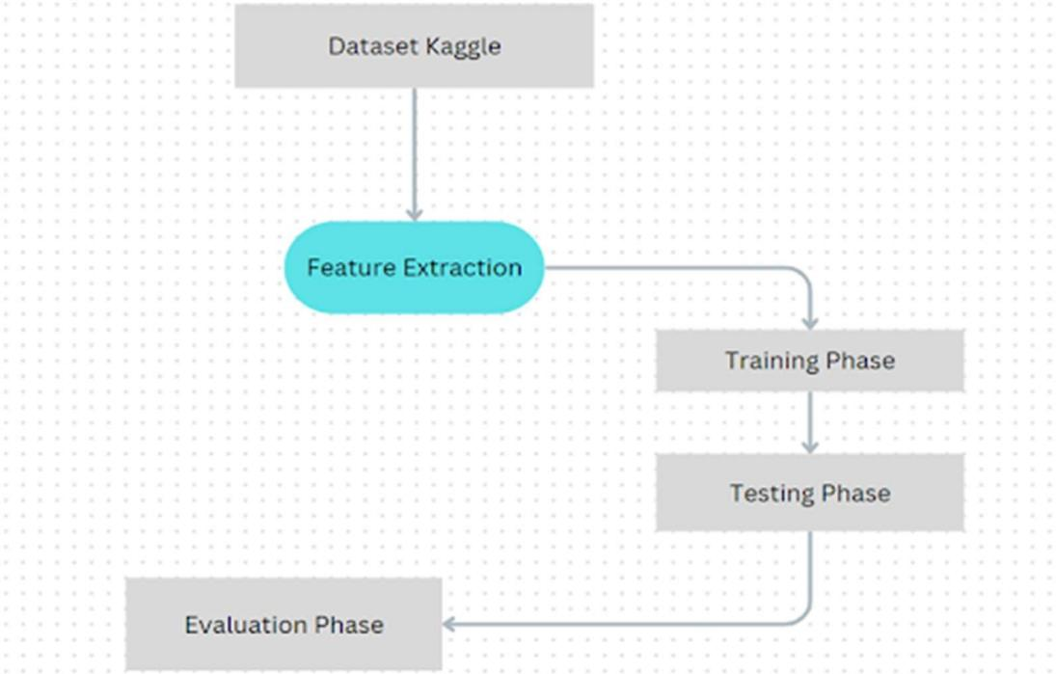

Figure 3.2.7.1 Flow Chart

I have been able to predict whether websites are good (legitimate) or bad (phishing) via URLs in this project. Datasets were searched online and discovered before running any code, which led to the development of code snippets needed to extract the feature after gathering the phishing and estimated websites from open source platforms. There are various kinds of URLs, including malicious, phishing, spam, and benign URLs. Owing to that fact, I decided to take the dataset from Kaggle. The datasets have been reviewed, pre-processed, and separated into training and test sets. I employed the enlisted machine learning algorithms and deep learning algorithm to categorize URLs, ultimately finding that Gradient Boost yielded the highest accuracy among the algorithms considered. Subsequently, the trained Gradient Boost model was saved for future use. To create an intuitive user interface,a Flask application was developed with two HTML pages: index.html and result.html. Flask application, defined in the app.py file, was executed on the local system, providing a practical platform for users to interact with the trained model.
Numerous training implementations for this project and the prediction of the legitimacy of phishing websites were carried out and tested. Some of the supervised algorithms with deep learning algorithms have been used. An overview of the process is described below:
- •Firstly, some libraries such as pandas, numpy, and matplotlib were imported, as well as Decision Tree Classifier and many more.
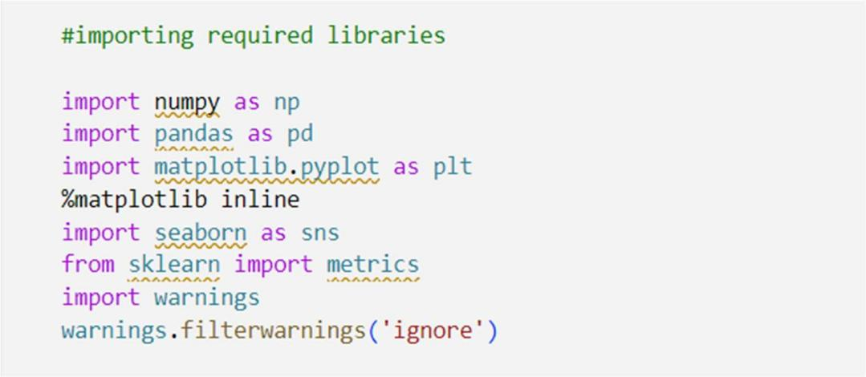

Figure 3.2.7.2 Imported Libraries

- •Analyzing the dataset from Kaggle consisting of 32 features.

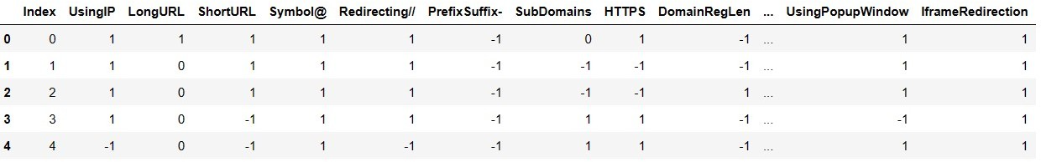
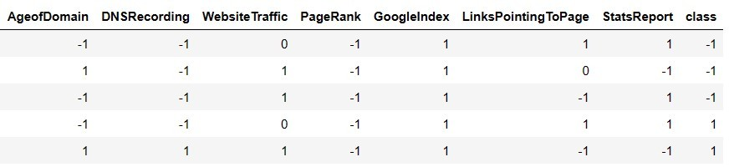
Figure 3.2.7.3 Dataset Features

- •Feature Extraction Process
- •Using IP

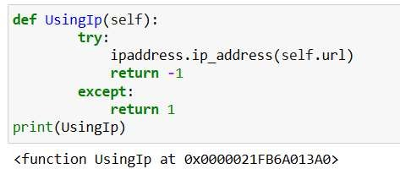
Figure 3.2.7.4 IP Address
- •Long URL
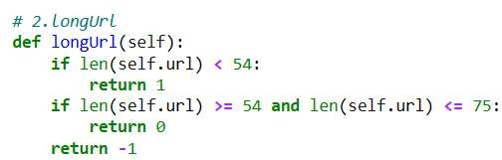

Figure 3.2.7.5 Long URL Extraction
- Short URL

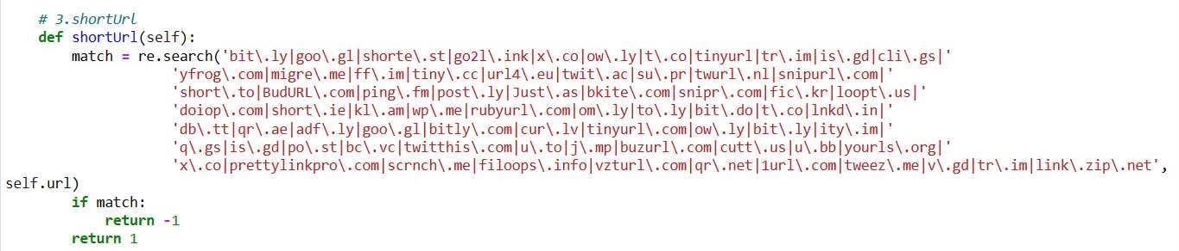
Figure 3.2.7.6 Short URL Extraction

- •Symbol@

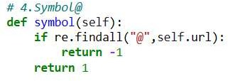
Figure 3.2.7.7 @Symbol Extraction
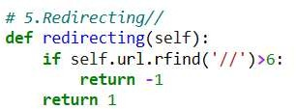
- •Redirection “//” in URL

Figure 3.2.7.8 Redirection of (//) Symbol
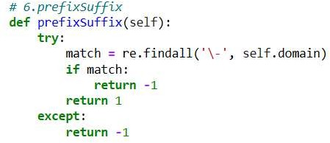
- •Prefix Suffix

Figure 3.2.7.9 Prefix and Suffix Extraction
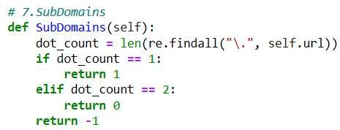
- •Sub Domains

Figure 3.2.7.10 Sub Domains
- •HTTPS
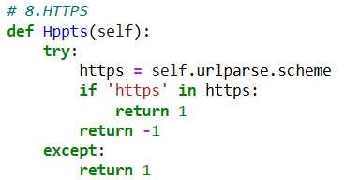

Figure 3.2.7.11 Extraction of HTTPS
- •Domain Length

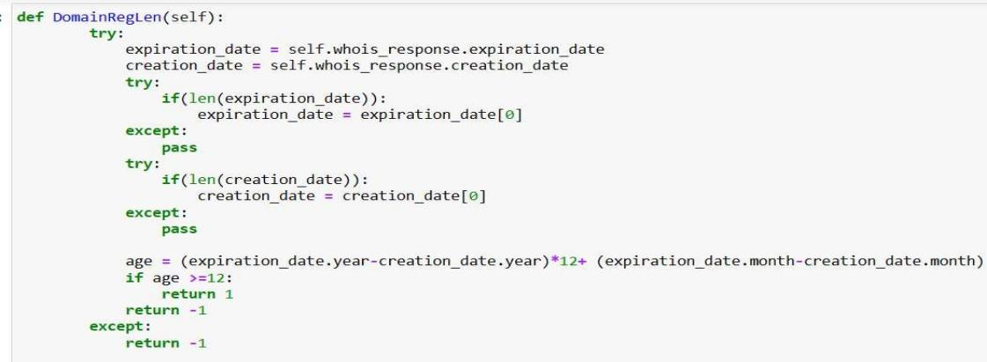
Figure 3.2.7.12 Domain Length
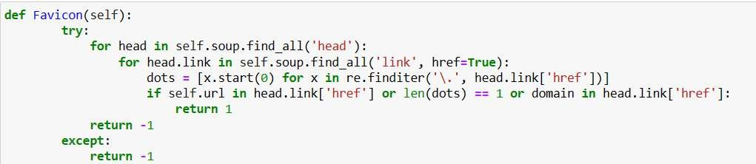
- •Favicon

Figure 3.2.7.13 Favicon
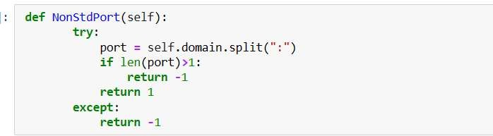
- •NontdPort

Figure 3.2.7.14 Std Port Extraction

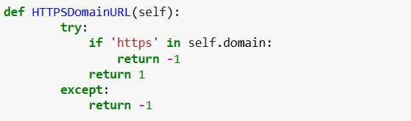
- •HTTPS Domain URL

Figure 3.2.7.15 Domain URL Extraction
- •Request URL
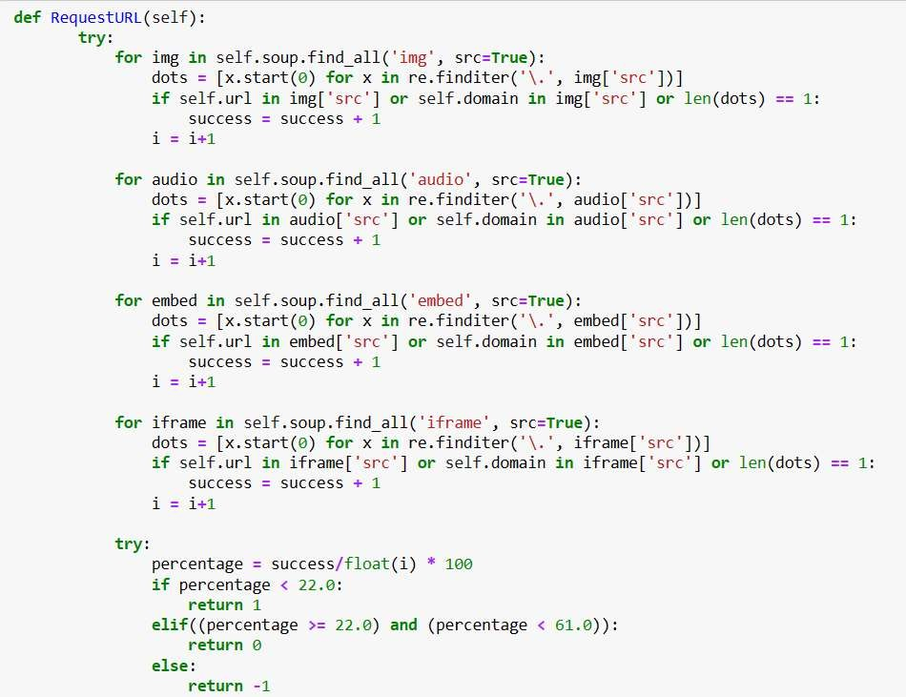

Figure 3.2.7.16 Request URL

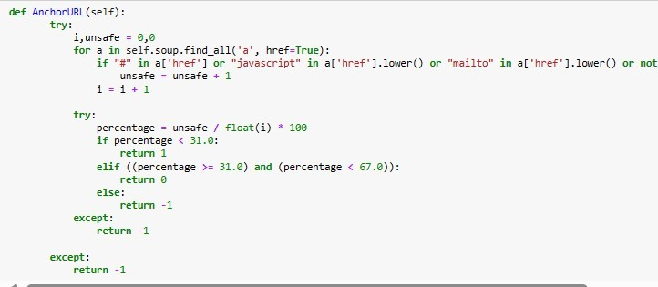
- •Anchor URL

Figure 3.2.7.17 Anchor URL Extraction
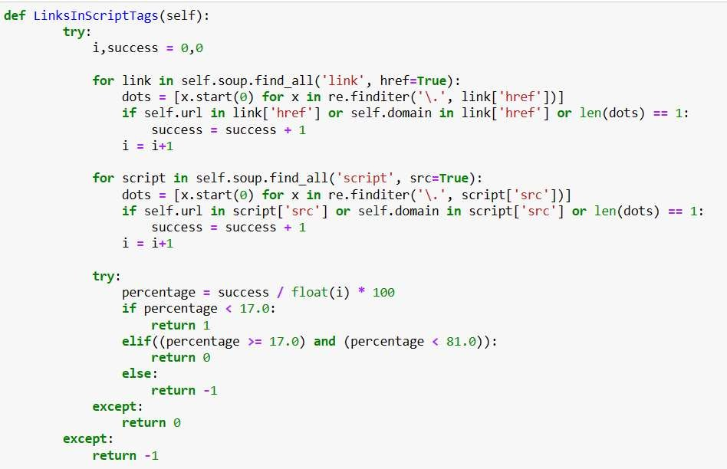
- •Script Tags

Figure 3.2.7.18 Script Link Tags

- •Server Handler
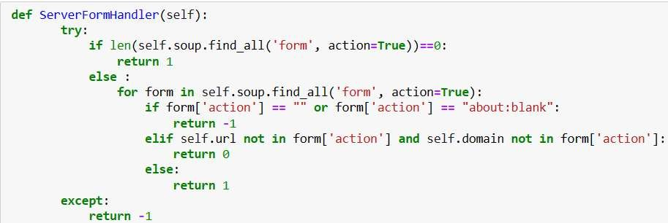

Figure 3.2.7.19 Server Handler Captioning
- •Email Info
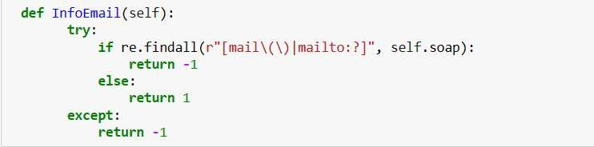

Figure 3.2.7.20 Email Information
•
- Abnormal URL

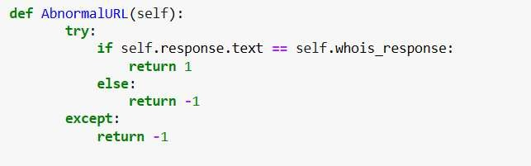
Figure 3.2.7.21 Abnormal URL Extraction
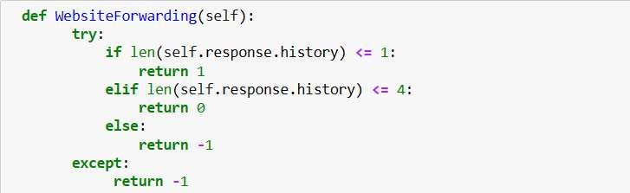
- •Website Forwarding

Figure 3.2.7.22 Website Forwarding Response
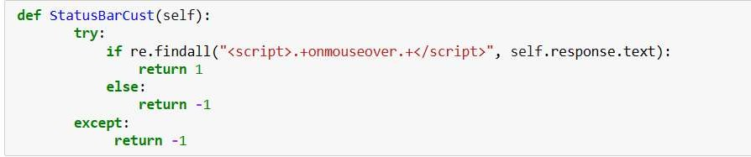
- •Status

Figure 3.2.7.23 Status Bar Finder
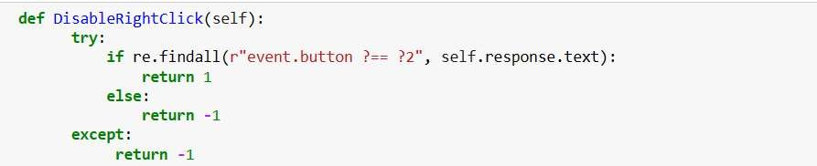
- •Disable Right Click

Figure 3.2.7.24 Disable Right Click

- •Using Popup Window
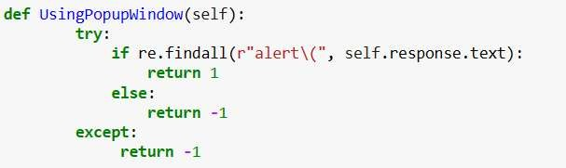

Figure 3.2.7.25 Popping Window
- •Iframe Redirection
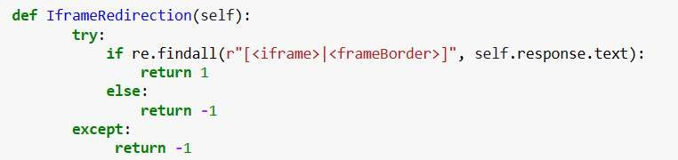

Figure 3.2.7.26 Redirection of Iframe
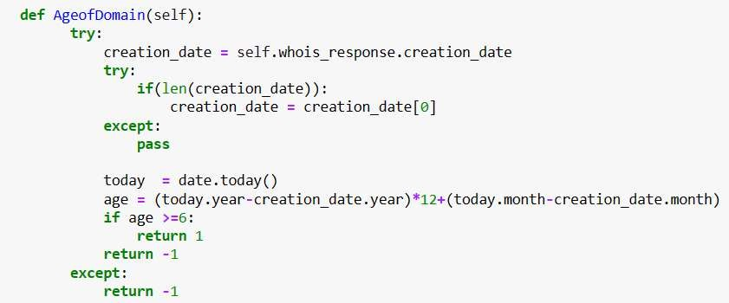
- •Age of Domain

Figure 3.2.7.27 Age Domain Handler

- •DNS Recording

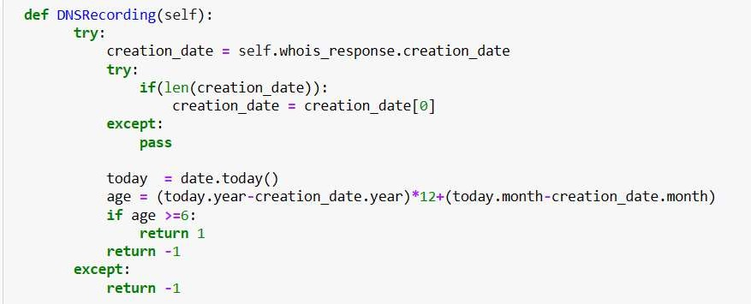
Figure 3.2.7.28 DNS Recording Handler
- •Page Rank
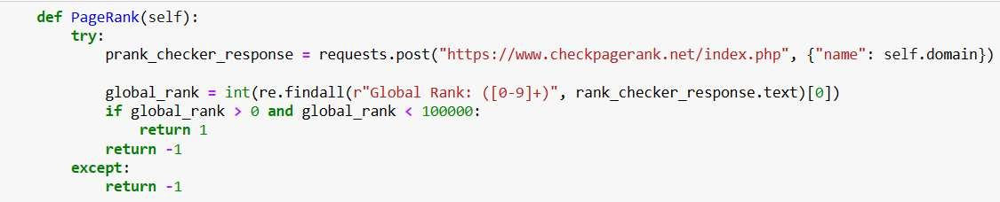

Figure 3.2.7.29 Page Rank Response Checker
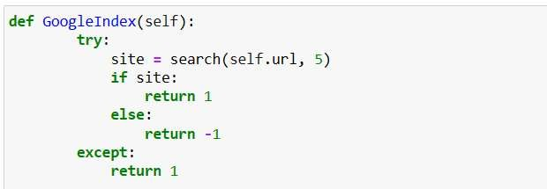
- •Google Index

Figure 3.2.7.30 Google Index Handler

- •Links Pointing To Page
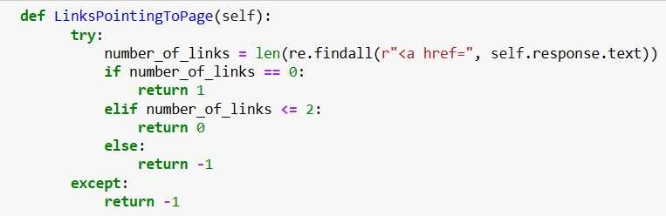

Figure 3.2.7.31 Number of Links Pointing
- •Stats Report

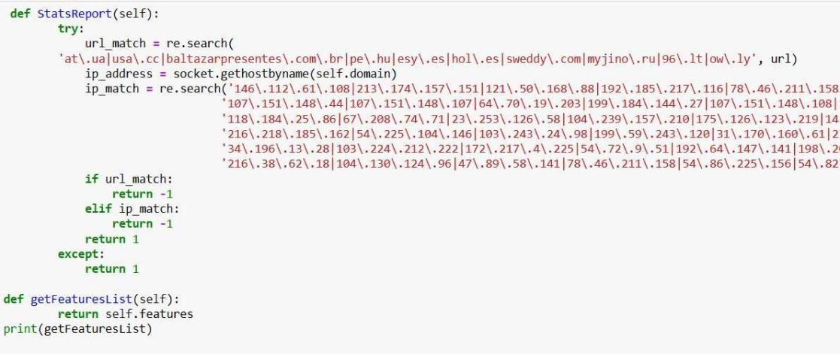
Figure 3.2.7.32 Matching Stats Report

3.3 System Design Methodology
System design methodology refers to the structured framework adopted to develop, train, test, and implement the phishing website detection model.
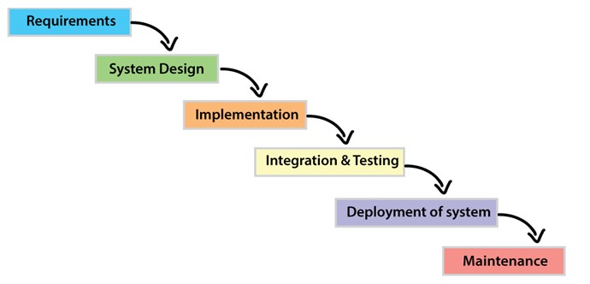
The Waterfall model was used as the software development methodology. The Waterfall model is a traditional, linear SDLC approach where each phase is completed before the next begins. In our context, this means we will proceed sequentially through: requirements analysis, system design, implementation, testing, deployment, and maintenance. The waterfall model involves a sequential approach to software development, where each phase is completed before moving on to the next one. This structured approach fits the project because the requirements (a phishing-check web app) are relatively well-defined upfront, allowing thorough specification before coding.
Under Waterfall, a detailed documentation is produced at each stage. For example, a Software Requirements Specification (SRS) is generated that clearly lists all system requirements. Then design documents (high-level and low-level designs) will be created before any coding begins. After implementation, rigorous integration and system testing will be conducted before final deployment. The advantages of this model include clear milestones, easy progress tracking, and comprehensive documentation (SRS, design docs) to guide development and future maintenance.

3.3.1 Requirement Specification
The first major deliverable is the Requirements Specification. All functional and non-functional needs will be compiled into a Software Requirements Specification (SRS) document. This SRS serves as a contract and guide: it captures what the system must do and how it should perform. As noted in the Waterfall tutorial, “These analyzed requirements are documented in a software requirement specification (SRS) document. SRS document serves as a contract between the development team and customers”. The SRS will help ensure that developers and stakeholders have a shared understanding of scope. The SRS will include descriptions of every use case and system feature (functional requirements), plus performance, security, and environmental constraints (non-functional requirements).

3.3.2 Functional Requirement Specification
Functional requirements describe the specific features and operations the system must provide. According to software engineering references, “the Functional Requirement Specification (FRS) outlines all the functions the software or product must perform”. In this case, key functional requirements might include:
- •User Authentication and Access Control: The current system is a Free-For-All. It doesn’t provide an optional authentication system with session management. The system shall allow users to submit or input a website URL for analysis.
- •Data Collection and Entry: The system shall accept a URL input from the user and analyze it using the ML model. The system shall extract relevant features from the URL and web page content( e.g. domain properties, HTML patterns, external links). This information helps the model make predictions.
- •Data Preprocessing: Before using the data, the system should clean and prepare it. This includes fixing missing values, removing errors, and converting text into numbers the model can understand.
- •Model Training and Updating: The system must allow training the predictive model using historical data. It should also support retraining when new data becomes available to improve accuracy and return a clear result (e.g. “Phishing” or “Legitimate”) for each submitted URL.
- •Risk Prediction: After training, the system should predict possible risks from new data. It should sort URLs into risk levels (malicious, phishing, spam, benign) and suggest possible recommendations and display the analysis outcome and any relevant information (such as confidence score or reasons) to the user.
- •Activity Logging and Audit Trail: All key actions (e.g., login, data changes, model updates) must be recorded. This helps in tracking activities and fixing issues when needed.
- •Admin Controls (if applicable): Authorized administrators may upload new phishing data or retrain the model to improve accuracy. The system shall provide administrative functions (for an admin user) to update the underlying dataset, retrain the model, and manage system configurations.
- •Data Storage and Retrieval: URL data and prediction results should be saved safely in a database. The system should allow users to easily find and review past records.

3.3.3 Non-Functional Requirement Specification
Non-functional requirements (NFRs) define how the system performs its tasks—its quality attributes. They include constraints like performance, reliability, usability, security, etc. As one source summarizes, non-functional requirements focus on attributes such as “performance, security, scalability, and usability” (whereas functional requirements describe what the system does). For this web-based phishing detector, the important NFRs include:
- •Performance: The system should respond quickly. For instance, each URL submission should be processed and a result returned in under 10 seconds.
- •Availability/Reliability: The web service should be highly available (e.g. >99% uptime) and handle concurrent users without crashing.
- •Usability: The web interface must be user-friendly and clear, so that non-technical users can easily enter URLs and understand results.
- •Security: The system must protect user data and prevent unauthorized access. For example, communications in transit should use HTTPS, and user credentials must be stored securely.
- •Scalability: The architecture should allow horizontal scaling (e.g. on cloud servers) to accommodate growth in usage.
- •Maintainability: The codebase and design should be version-controlled (GitHub), modular and well-documented so that future developers can update or extend the system easily.
- •Portability: The system should run on standard web platforms (it will be based on Flask/Python and standard web frameworks).
- •Deployment: The system will be built with the Flask web framework, hosted on a platform like Render, and integrated with continuous deployment from the GitHub repository. This ensures the system is web-based and easily accessible to users.

3.4 System Design

3.4.1 Use Case Diagram
The primary actors are the User and an Administrator. The User can submit a URL for analysis. After submitting the URL, the system (Phishing Detector) extracts features and classifies the URL using the trained model. The User then receives the result (phishing or safe). The Administrator actor is responsible for managing the ML model (e.g. uploading a new Random Forest model version or retraining) and monitoring system status. These interactions are represented in the use case diagram.
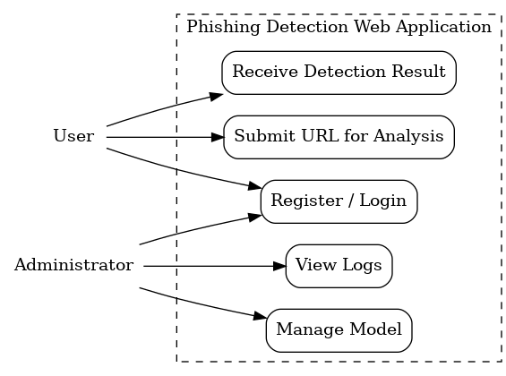

Figure 3.4.1 Use Case Diagram

3.4.2 Activity Diagram
The activity diagram models the workflow from user input to classification. It describe the steps as follows: first, the User logs in or registers if necessary, then enters a URL. The system retrieves the saved model and extracts features from the URL. Next, the features are fed into the machine learning classifier, which produces a prediction. Finally, the system displays the result to the user and the activity ends. In essence, it is a flowchart of actions and decisions.
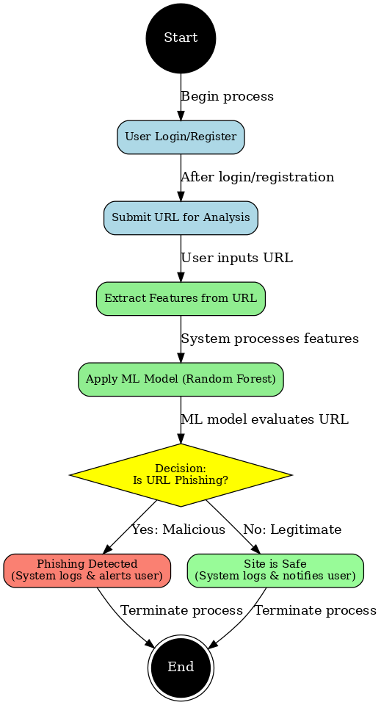

Figure 3.4.2 Activity Diagram

3.4.3 Class Diagram
A UML class diagram identifies the system’s main classes, attributes, methods, and relationships. In general, class diagrams “describe the structure of a system by showing classes, their attributes, operations (or methods), and the relationships among objects”.
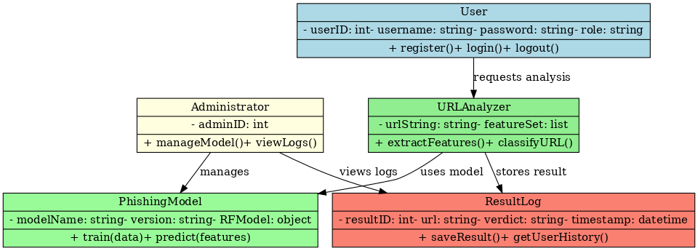

Figure 3.4.3 Class Diagram

3.4.4 Data-Flow Process of the System
Data Flow Diagram (Context/Level-0)
The Level-0 DFD shows how external entities interact with the system and how data moves through it. Here the main external entities are the User and the Administrator. The core process is Phishing URL Analysis. Key data stores include the Model Store (holding the trained Random Forest model and possibly feature extractors) and a User/Result Database. Data flows include:
- •User → (Process) Phishing URL Analysis: The user sends input data (login credentials and URL to check).
- •(Process) → Model Store: The system reads the model (trained Random Forest) from storage.
- •(Process) → (Process) Internal: Within the process, the URL is checked. (Feature extraction and classification occur internally.)
- •(Process) → User: The system returns the classification result (e.g. “phishing” or “safe”) as output.
- •Admin → (Process): An administrator can update the Model Store (via model upload or retraining).

Figure 3.4.4 Data-Flow Process

3.5 Summary
In this chapter, a thorough analysis of both existing anti-phishing approaches and the proposed solution was conducted. It was discovered that traditional methods (blacklists and fixed heuristics) are limited by their inability to adapt to new threats. To address this, the proposed system uses machine learning and a modern web framework, enabling real-time classification of any URL via a Flask-based interface. An adoption of the Waterfall model was made to systematically develop the system: first gathering and specifying requirements (functional and non-functional), then designing and implementing the solution, and finally planning rigorous testing and deployment. All requirements have been documented in an SRS, and the system architecture has been captured using UML diagrams (use-case, activity, class) and a data-flow diagram. Finally, an outline was drafted for a cloud-based deployment plan (GitHub + Render) to make the application accessible online. The next chapter will describe the implementation and testing of this design.

